Software Design Approaches - Object-Oriented

📖 Definition
# Source: AI Source: Provided by: [Data Path: Persons Table -> ID Column: 1, Name_En Column: Motasem Essam] -> From: [ChatGPT] on [1/23/2026]
Object-Oriented Design (OOD) is a software design approach that organizes a system using objects and classes, where each object represents a real-world entity containing data (attributes) and behavior (methods).
👉 In simple terms:
“Design software by modeling real-world objects and their interactions.”

⚙️ How It Works
# Source: AI Source: Provided by: [Data Path: Persons Table -> ID Column: 1, Name_En Column: Motasem Essam] -> From: [ChatGPT] on [1/23/2026]
- Identify objects in the system (e.g., User, Product, Order)
- Define attributes (data) and methods (functions) for each object
- Establish relationships between objects
- Implement the system using classes and objects

🧩 Core Principles of OOD
# Source: AI Source: Provided by: [Data Path: Persons Table -> ID Column: 1, Name_En Column: Motasem Essam] -> From: [ChatGPT] on [1/23/2026]
🔒 Encapsulation
- Bundles data and methods together
- Restricts direct access to internal data
🧬 Inheritance
- Allows one class to inherit properties from another
- Promotes code reuse
🔁 Polymorphism
- Same method behaves differently depending on the object
🎭 Abstraction
- Hides complex implementation details
- Shows only essential features

🧱 Key Characteristics
# Source: AI Source: Provided by: [Data Path: Persons Table -> ID Column: 1, Name_En Column: Motasem Essam] -> From: [ChatGPT] on [1/23/2026]
- Based on classes and objects
- Promotes reusability and flexibility
- Uses UML diagrams (class diagrams, sequence diagrams)
- Models real-world systems effectively

✅ Advantages
# Source: AI Source: Provided by: [Data Path: Persons Table -> ID Column: 1, Name_En Column: Motasem Essam] -> From: [ChatGPT] on [1/23/2026]
- Reusability: Code can be reused through inheritance
- Maintainability: Easier to update and modify
- Scalability: Suitable for large systems
- Real-world modeling: Intuitive design approach

⚠️ Disadvantages
# Source: AI Source: Provided by: [Data Path: Persons Table -> ID Column: 1, Name_En Column: Motasem Essam] -> From: [ChatGPT] on [1/23/2026]
- Complexity: Can become complicated with many classes
- Performance overhead: Due to abstraction layers
- Steep learning curve for beginners

🎯 Use Cases
# Source: AI Source: Provided by: [Data Path: Persons Table -> ID Column: 1, Name_En Column: Motasem Essam] -> From: [ChatGPT] on [1/23/2026]
- Enterprise applications
- GUI-based systems
- Large-scale software projects
- Systems with complex interactions

🛠️ Simple Example
# Source: AI Source: Provided by: [Data Path: Persons Table -> ID Column: 1, Name_En Column: Motasem Essam] -> From: [ChatGPT] on [1/23/2026]
Problem: Online Shopping System
Classes:
- User
- Product
- Order
Example:
- User → name, email, login()
- Product → price, description, display()
- Order → totalAmount, placeOrder()
👉 Objects interact to complete tasks like purchasing products.

🔄 OOD vs Other Approaches (Quick Insight)
# Source: AI Source: Provided by: [Data Path: Persons Table -> ID Column: 1, Name_En Column: Motasem Essam] -> From: [ChatGPT] on [1/23/2026]
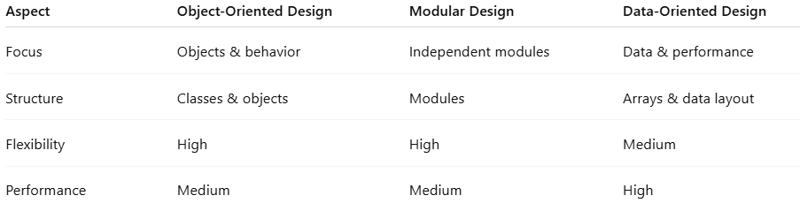
Aspect | Object-Oriented Design | Modular Design | Data-Oriented Design
Focus | Objects & behavior | Independent modules | Data & performance
Structure | Classes & objects | Modules | Arrays & data layout
Flexibility | High | High | Medium
Performance | Medium | Medium | High

📌 Summary
# Source: AI Source: Provided by: [Data Path: Persons Table -> ID Column: 1, Name_En Column: Motasem Essam] -> From: [ChatGPT] on [1/23/2026]
Object-Oriented Design (OOD) is a powerful approach that structures software around objects and their interactions. It supports reusability, scalability, and maintainability, making it ideal for complex systems. However, it can introduce complexity and performance overhead if not designed carefully.

